# Philips Hue Bulbs Guide

## How to Setup the Philips Hue Starter Kit

### Before beginning setup:

1. Plug in your Hue Bridge to an outlet.
2. 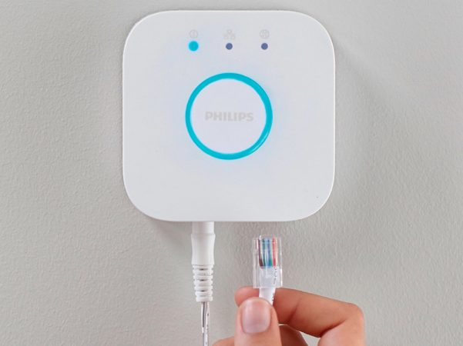Connect the Hue Bridge to your Wi-Fi router using the included Ethernet cable.

Hue Bridge

1. Wait for the three lights to turn on.
2. Place your bulbs in lamps or fixtures and make sure they’re connected to power.

[Source](https://www.philips-hue.com/en-us/support/connect-hue-product/starter-kit)

### Set up the starter kit:

1. Download the Hue app from the [App Store](https://apps.apple.com/us/app/philips-hue-gen-2/id1055281310?ls=1).
2. Open the Hue app. Make sure your iPad is connected to the same Wi-Fi network as the Hue Bridge.
3. Follow the on-screen instructions to connect your Hue Bridge to the app.
4. When your Hue Bridge is successfully connected, the Hue app will search for lights. Follow the on-screen instructions to complete the setup.
   1. When adding new lights, be very specific with their naming so as to not be confused later on.

## General Information & Hue App Instructions

* The Hue Bridge can have up to 50 lights connected to it

### Hue App Instructions:

Initially, create a Hue account as it will be useful to have later on.

The Hue app has 5 tabs at the bottom of the screen to control the app. The only 2 that are necessary for basic setup are “Home” and “Settings”.

Home displays the different Rooms and Zones within a home. Rooms and Zones are made up for Hue lights that are connected to the Hue Bridge (up to 50 lights for the entire home).

From Home, lights, Rooms, and Zones can all be added by pressing the button containing the three dots surrounded by a circle in the top right corner of the app and then by pressing “Add Lights”.

Lights added to the Hue Bridge can be moved into different Rooms and Zones depending on what Room or Zone they correspond to.

So, what are Rooms and Zones? Well, if you press on the button containing the three dots, and the press “Add new Room or Zone” the app will tell you the difference.

* Room: A physical room in your house, e.g., bedroom, living room, kitchen.
* Zone: A group of lights that you control simultaneously, e.g., the whole downstairs floor or TV area

Within each Room or Zone (after being selected with a press), Scenes can be created. Scenes are specific settings for lights that can be set. Examples include dimming all lights in the Bedroom to 50% or dimming all lights in the kitchen to 25%.

## Connecting Philips Hue with Alexa

Any Alexa-compatible device works with the hue lights. All that is needed in addition to the setup above is the Alexa Device and the [Alexa App](https://apps.apple.com/us/app/amazon-alexa/id944011620).

The Alexa app requires an Amazon Account to sign in. Once signed in, navigate to the “More” tab, then tap “Skills & Games”.

Tap the search icon in the top right corner and type “Philips Hue” in the search bar. Tap the Hue skill. Tap enable to use.

The Alexa App will redirect you to your Philips Hue Account page. Sign into the account.

Select the Hue bridge (already setup from before) to link and tap “Next”. Tap “Agree and Continue”, then tap “Close”.

Each Hue Device can be added to a location within the Alexa App to make the voice commands work properly. Make sure to match these with the Grid commands.

Now your lights can be controlled through voice commands contained within the Grid App.